**EXCEL ASSIGNMENT 16**

1. What is a Macro? How is it useful in excel or in your daily work?

A macro is a set of instructions used to execute repetitive task. We can record a set if commands and then play them back with one or two keystrokes. That means we can save a lot of time when doing routine and repetitive tasks.

1. What is VBA? Write its full form and briefly explain why VBA is used in

excel?

VBA stands for Visual Basic Analysis. Excel VBA is Microsoft’s programming language for office applications such as MS-Excel, MS-Word and MS-Access. Macros are what most people who write VBA Code use.

1. How do you record a macro? Write detailed steps to create a macro to

automatically make the following table in bold and to create borders for

it in excel.

hi 78

hello 69

ineuron 45

On the developer tab, click Record Macro. Optionally, enter a name for the macro in the Macro name box, enter a shortcut key in the shortcut key box, and a description in the Description box, and then click OK to start recording.

Steps to create a macro for the given table are:

* Go to Develop tab click on record macro

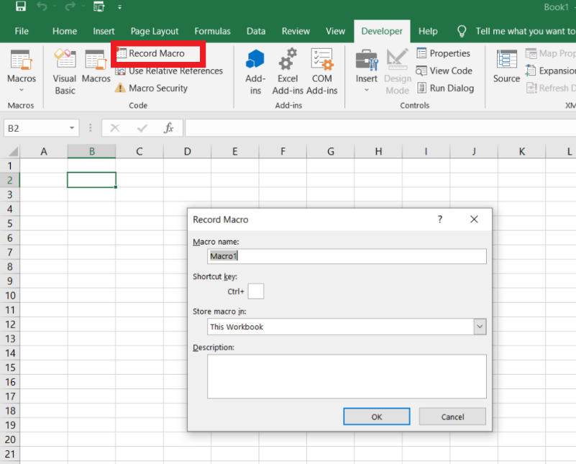

* Give the name, shortcut key and description of the table and click OK.

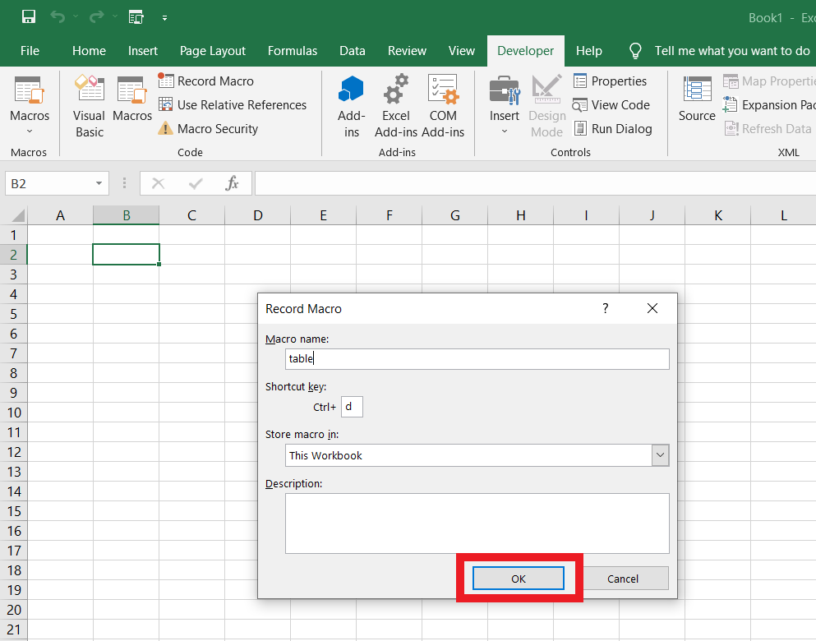

* Create table

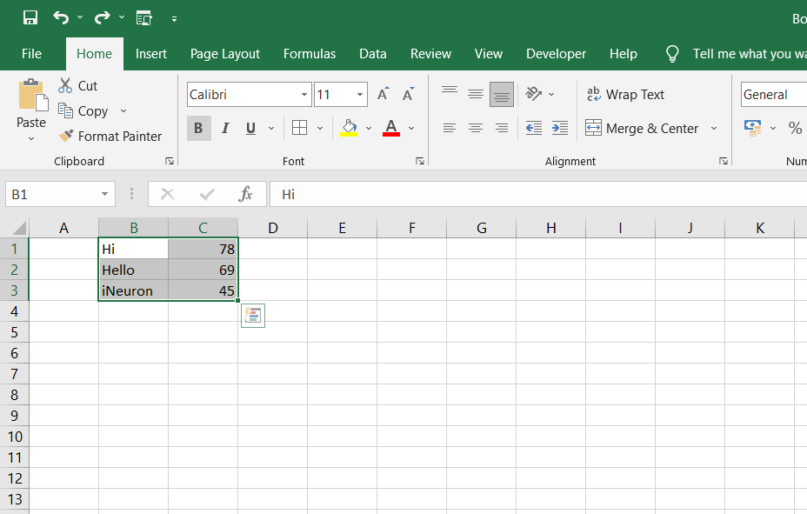

* Do all the formatting in the table. E.g. Bold, adding border etc.

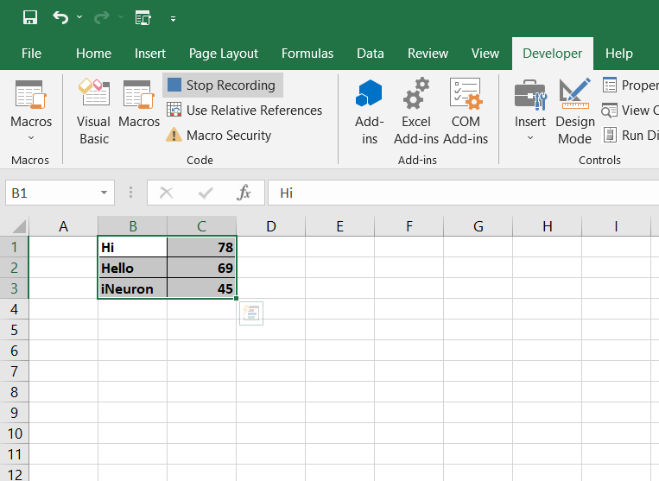

* After doing all the formatting, click on **Stop Recording from** the develop tab.

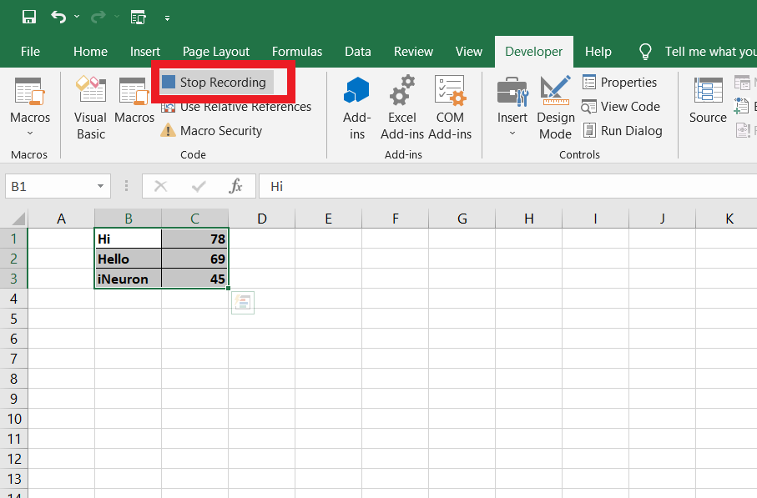

1. What do you mean when we say VBA Editor?

Microsoft Visual Basic for Applications (VBA) enables non-programmers to record, create, and edit macros that can automate tasks in Office applications.

1. Briefly describe the interface of a VBA editor? What is properties

window? And what is watch window? How do you display these

windows?

We can open the VBA interface by using the ALT + F11 keyboard shortcut, or we can go to the Developer tab and click on Visual Basic.

**Properties Window:** It is used to display properties for objects selected in two main types of window available in the Visual Studio integrated development environment (IDE).

**Watch Window:** It makes it convenient to inspect, audit, or confirm formula calculations and results in large worksheets.

To display these windows :

Select Start > Settings > Display.

1. What is an immediate Window and what is it used for?

Immediate window is a small box in the Visual Basic Editor that we can use to execute a single line of code and get an Instant result of that. In simple words, instead of executing our code directly in Excel, we can run a macro line to what it returns. It’s quite useful when we are debugging a code.

The Immediate Window displays information resulting from debugging statements in your code or from commands types directly into the window. From the View menu, choose immediate window (CTRL _ G).